**Sprite Sheets Animation**

**(JUNGLE SCENARIO)**

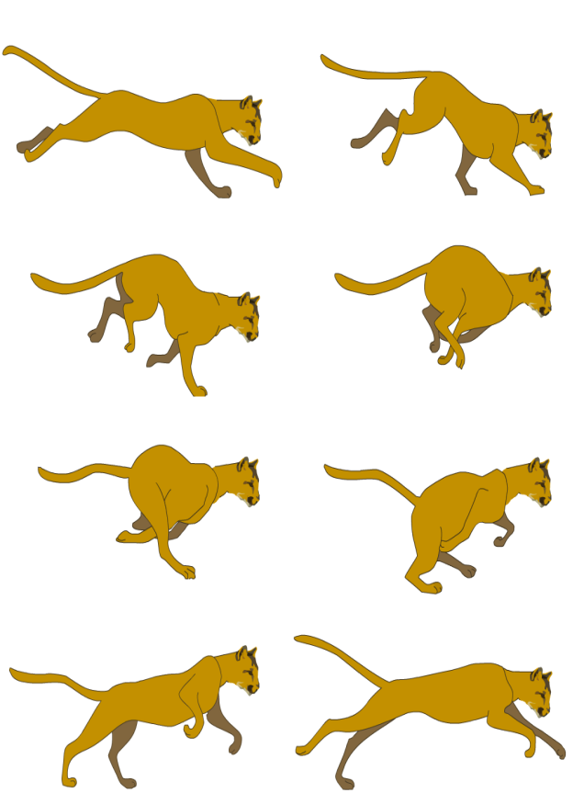**Sprite Sheets Used :**

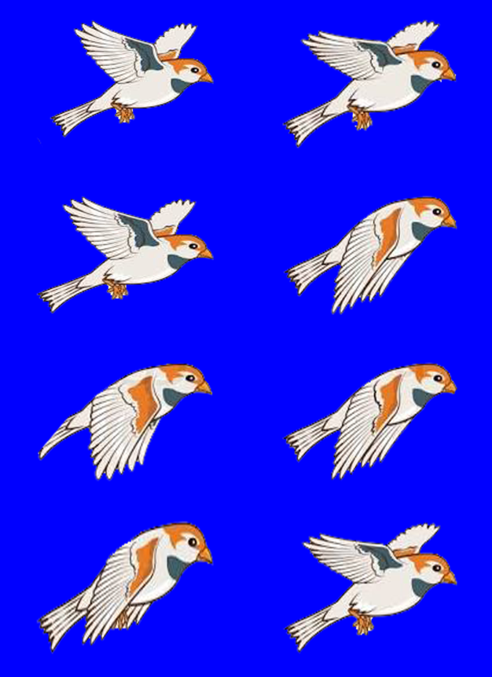

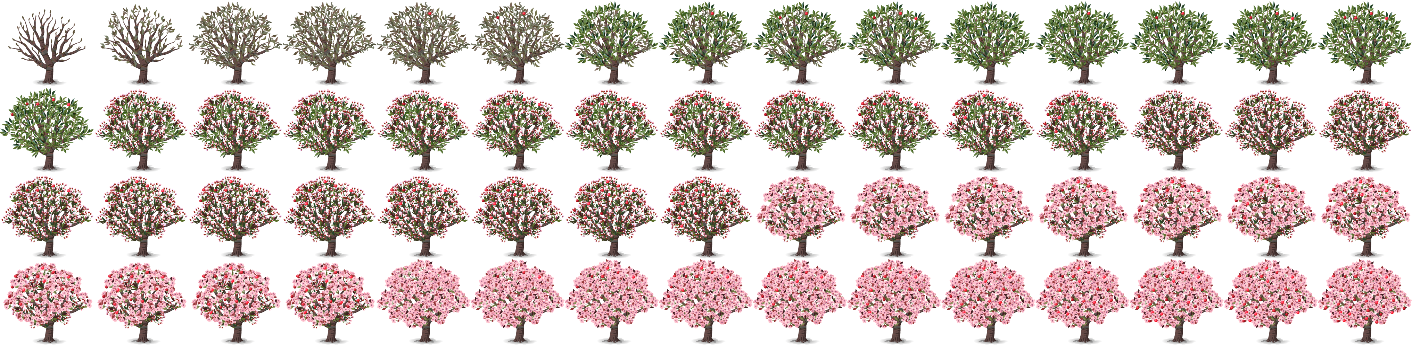

**Resultant Scenario:**

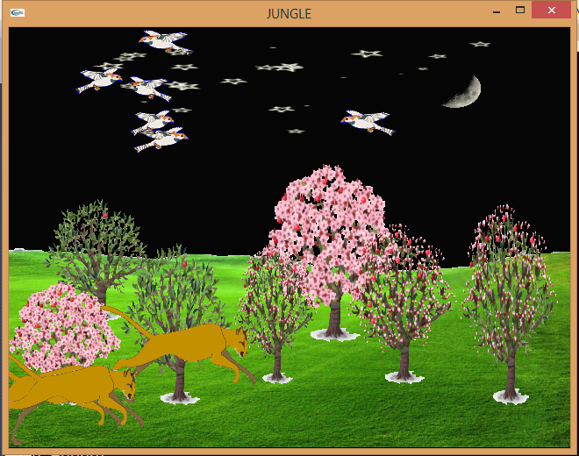

In this Scenario, a jungle sketch is drawn displaying some birds flying in the sky, some Big Cats running here and there, and Trees having growing animation.

Background Color is also changing from darker to lighter to capture the time changing effect. Stars and Sun are also drawn at different time interval to give it a realistic effect. Also grass image is drawn to give this scene A Jungle Effect.

**How This Animation Works:**

Let Consider the movement of Big Cats. How It is giving movement effect.

Its just cut pasting image on polygon by mean on texturing. Consider the following image for more clarification:

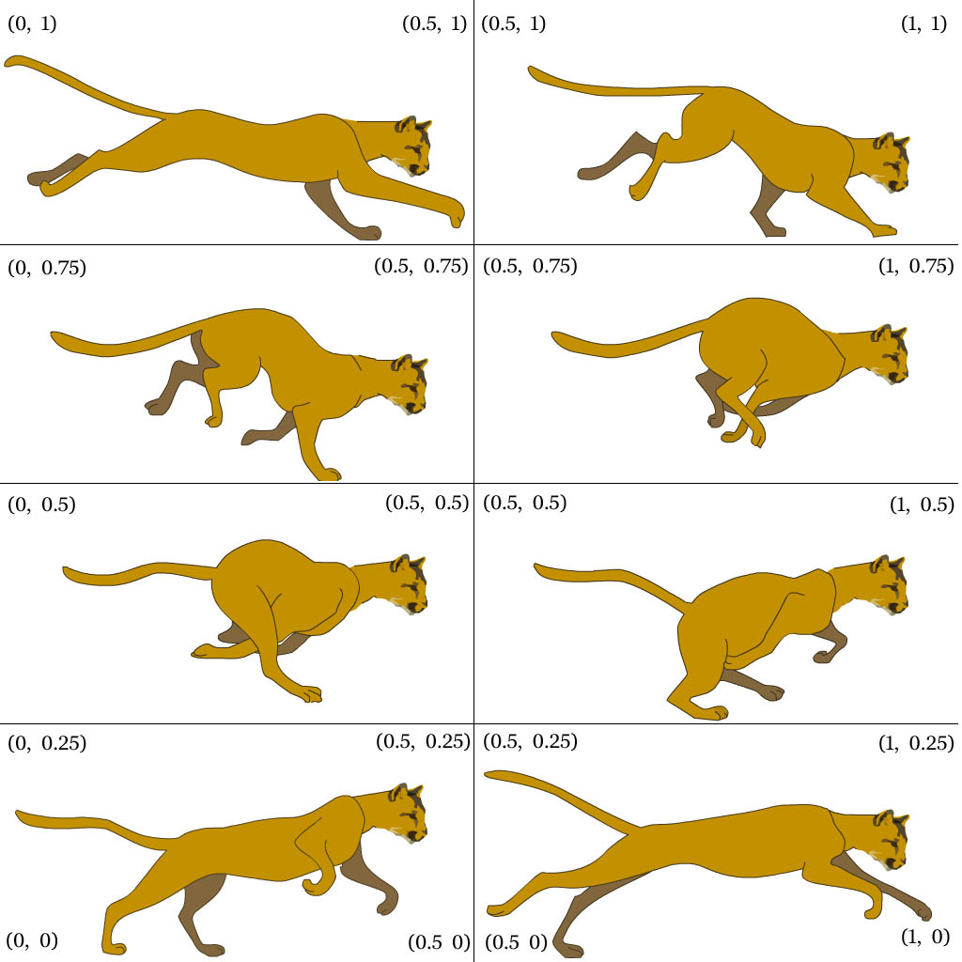

For this animation of Running Cat, a simple polygon is drawn textured with coordinates (0,0), (0.5,0), (0.5,0.25) and (0,0.25) respectively. By doing this, the bottom left image of cat will be drawn on the screen. Now, for giving animation effect, the bottom right image should be drawn, that could be done using timer function by incrementing the texture coordinates accordingly. Same work should be done for further animation effects.

Some code snippets for justification:

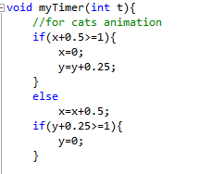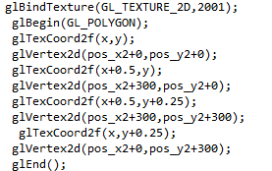

pos_x2 is used for moving it here and there. Image Switching logic for cat animation

**How These Coordinates are Selected:**

Since the Coordinates for texturing image vary from 0 to 1, we can determine coordinates easily by dividing them by number of image per row or column.

For Example, consider above sprite sheet of cats, there are two image per row, so we get coordinate difference by calculating (1/2) i.e 0.5 . Same process is done vertically, (1 / 4 ) i.e 0.25.

Let Consider tree sprite given above, for that, horizontally it will have a difference of ( 1 / 15 ) between each texture coordinate as there are 15 images per row.